Pet-Clinic DDL

**Refer the below database schema:-**

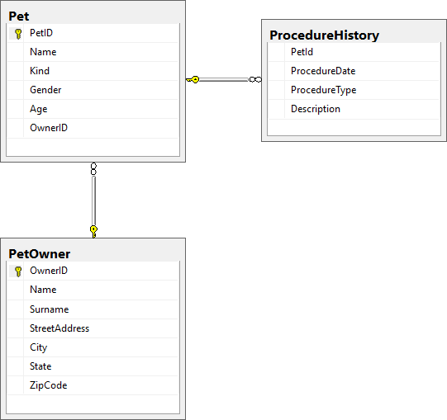

**Note:**You may ignore the relationship between tables while creating them.

1.    Create tables as per the description given below:-

**Table Name:**PetOwner

|  |  |  |  |
| --- | --- | --- | --- |
| **Column Name** | **Data Type** | **Size** | **Constraints** |
| OwnerID | int |  | primary key |
| Name | char | 50 |  |
| Surname | char | 50 |  |
| StreetAddress | char | 100 |  |
| City | char | 100 |  |
| State | char | 10 |  |
| ZipCode | int |  |  |

CREATE TABLE PetOwner(

OwnerID int PRIMARY KEY,

Name char(50),

Surname char(50),

StreetAddress char(100),

City char(100),

State char(10),

ZipCode int) ;

**Table Name:**Pet

|  |  |  |  |
| --- | --- | --- | --- |
| **Column Name** | **Data Type** | **Size** | **Constraints** |
| PetID | char | 10 | primary key |
| Name | char | 20 |  |
| Kind | char | 10 |  |
| Gender | char | 6 |  |
| Age | int |  |  |
| OwnerID | int |  |  |

CREATE TABLE Pet(

PetID char(10) PRIMARY KEY,

Name char(20),

Kind char(10),

Gender char(6),

Age int

OwnerID int);

**Table Name:**ProcedureHistory

|  |  |  |  |
| --- | --- | --- | --- |
| **Column Name** | **Data Type** | **Size** | **Constraints** |
| PetId | char | 10 |  |
| ProcedureDate | date |  |  |
| ProcedureType | char | 50 |  |
| Description | char | 100 |  |

CREATE TABLE ProcedureHistory(

PetID char(10),

ProcedureDate date,

ProcedureType char(50),

Description char(100));

2.

a.    Write a T-SQL query to set DEFAULT value for the "State" column of PetOwner table as 'Michigan'

ALTER TABLE PetOwner  
ALTER State SET DEFAULT 'Michigan';

b.    Write a T-SQL query to add foreign key on OwnerID column of Pet table referencing to the primary key OwnerID of PetOwner table.

ALTER TABLE Pet  
ADD FOREIGN KEY (OwnerID) REFERENCES PetOwner(OwnerID);

c.    Write a T-SQL query to add foreign key on PetId column of ProcedureHistory table referencing to the primary key of Pet table.

ALTER TABLE ProcedureHistory  
ADD FOREIGN KEY (PetId) REFERENCES Pet(PetID);

**SAMPLE:  
<Line a..1>  : Your SQL CREATE Statement (do not use semicolon - ; to terminate)  
<Line a..n>  : GO**  
***<Line b..1>  : Your SQL CREATE Statement (do not use semicolon - ; to terminate)  
<Line b..n>  : GO***  
***<Line c..1>  : Your SQL CREATE Statement (do not use semicolon - ; to terminate)  
<Line c..n>  : GO***  
***<Line d..1>  : Your SQL ALTER Statement (do not use semicolon - ; to terminate)  
<Line d..n>  : GO***  
***<Line e..1>  : Your SQL  ALTER Statement (do not use semicolon - ; to terminate)  
<Line e..n>  : GO***  
***<Line f..1>  : Your SQL  ALTER Statement (do not use semicolon - ; to terminate)  
<Line f..n>  : GO***